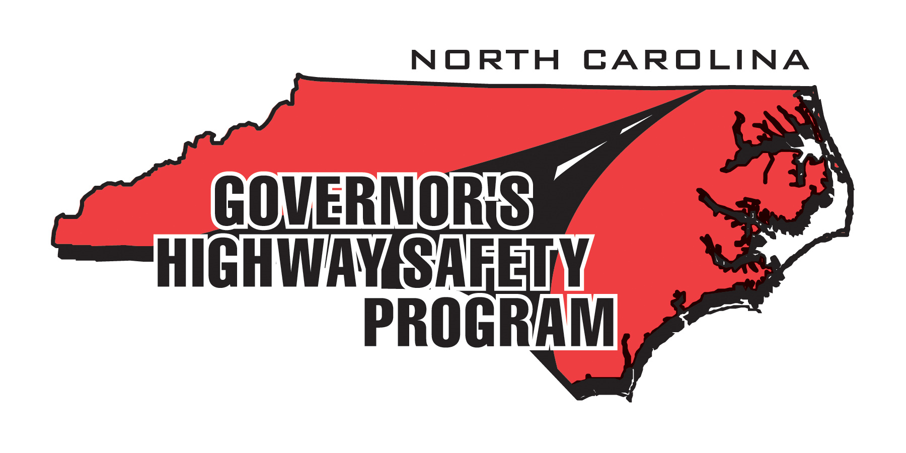

HIGHWAY SAFETY POSTER CONTEST ENTRY FORM

Posters must be no larger than 11" x 14" and in landscape format. Posters larger than 11” x 14” and in portrait format will be disqualified. All posters may be submitted as a PDF.

ALL ENTRIES MUST BE EMAILED (.PDF) by 5:00 pm on OCTOBER 5, 2015 to jrbandy@ncdot.gov or mailed and POSTMARKED BY OCTOBER 2, 2015 to: Jonathan Bandy, c/o Governor’s Highway Safety Program, 1508 Mail Service Center Raleigh, NC 27699

Name of Artist:

Age of Artist:

Poster Title:

Parent/Sponsor Name:

Parent/Sponsor Agency:

Parent/Sponsor Email:

Parent/Sponsor Phone:

Local Newspaper Name:

Please submit this completed form and your poster by the deadline above.
No submissions will be accepted unless accompanied with this form.

